**NSDE Programming Assignment 2**

**Name – Keerti P. Charantimath Roll Number - 19MA20059**

Q1.

Matlab **Code:**

clear

x = 0:0.1:1;

n = length(x);

h = 0.1;

f2 = @(x,y) (6*y*y);

f3 = @(x,y) (12*x*y);

f4 = @(x,y) (72*x^3 + 12*y^2);

val = zeros(1,7);

g = zeros(1,7);

ans = zeros(1,n);

for j=1:7

if j==1

s=-9/5;

elseif j==2

s=-1.9;

else

s=val(j-1)-((g(j-1)/(g(j-1)-g(j-2)))*(val(j-1)-val(j-2)));

end

val(j)=s;

y = zeros(1,n);

y1 = zeros(1,n);

y(1) = 1;

y1(1) = s;

for i=1:n-1

y(i+1)=y(i)+h*y1(i)+(h*h/2)*f2(x(i),y(i))+(h*h*h/6)*f3(y(i),y1(i));

y1(i+1)=y1(i)+h*f2(x(i),y(i))+(h*h/2)*f3(y(i),y1(i))+(h*h*h/6)*f4(y(i),y1(i));

end

g(j)=0.25 - y(n);

ans = y;

end

act = zeros(1,n);

for i=1:n

act(i)=1/(1+x(i))^2 ;

end

fprintf('%5s %20s %20s\n','X','Actual Y','Calculated Y');

for i=1:n

fprintf('%5.4f %20.8f %20.8f\n',x(i),act(i),ans(i));

end

plot(x,ans,'*b');

hold on

plot(x,act,'r-');

hold on;

xlabel('X');

ylabel('Y');

grid on;

grid minor;

**Table:**

|  |
| --- |
| X Actual Y Calculated Y |
| 0.0000 1.00000000 1.00000000 |
| 0.1000 0.82644628 0.82583208 |
| 0.2000 0.69444444 0.69363849 |
| 0.3000 0.59171598 0.59090184 |
| 0.4000 0.51020408 0.50946171 |
| 0.5000 0.44444444 0.44380781 |
| 0.6000 0.39062500 0.39010784 |
| 0.7000 0.34602076 0.34562849 |
| 0.8000 0.30864198 0.30837732 |
| 0.9000 0.27700831 0.27687399 |
| 1.0000 0.25000000 0.25000000 |

**Graph:**

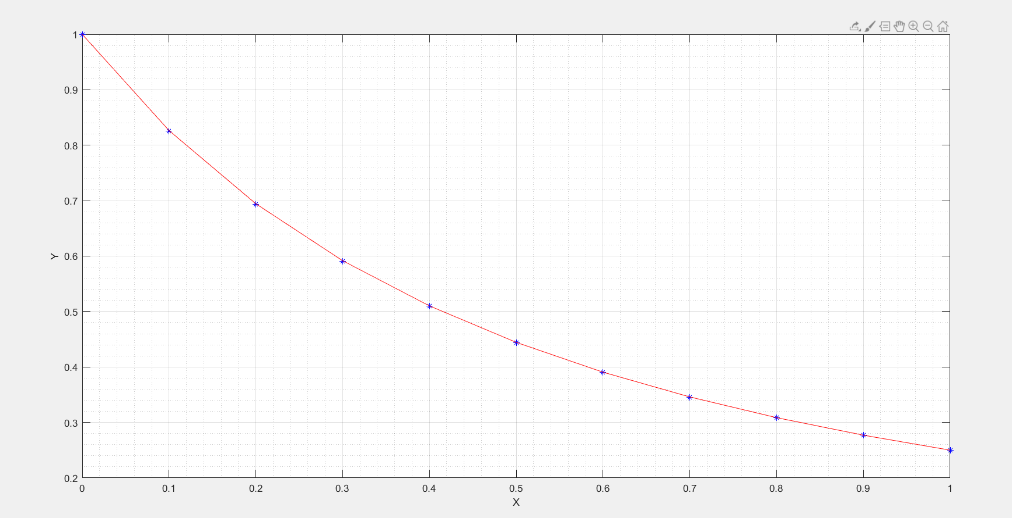

Q2.

Matlab **Code:**

%boundary value problem shooting meathod

clear

u=zeros(1,11);

v=zeros(1,11);

Du=zeros(1,11);

Dz=zeros(1,11);

phi=zeros(1,5);

Dphi=zeros(1,5);

s=zeros(1,6);

h= 0.1;

x=(0:0.1:1); %values of x

uf=1.0;

s(1)= 0.09;

for k=1:5

fprintf("\nFor s = %2.2f\n",s(k));

Du(1)=s(k);

u(1)=0; % u at x= 0 i.e. first element in column matrix u

v(1)=0; Dv(1)= 1;

for j=1:11

% taylor series of order 3

u(j+1)=u(j)+(0.1*Du(j))+(0.01*u(j)*Du(j))+((0.001/3)*(Du(j)*Du(j)+2*u(j)*u(j)*Du(j)));

Du(j+1)=Du(j)+(0.2*Du(j)*u(j))+((0.01)*(Du(j)*Du(j)+2*u(j)*u(j)*Du(j)));

% taylor series of order 3

v(j+1)=v(j)+(0.1*Dv(j))+(0.01*(Du(j)*v(j)+Dv(j)*u(j)))+((0.002/3)*(2*Du(j)*u(j)*v(j)+Du(j)*Dv(j)+Dv(j)*u(j)*u(j)));

Dv(j+1)=Dv(j)+0.2*(Du(j)*v(j)+Dv(j)*u(j))+0.02*(2*Du(j)*u(j)*v(j)+Du(j)*Dv(j)+Dv(j)*u(j)*u(j));

fprintf("u(%2.2f)=%12.8f \n",x(j),u(j));

plot(x(j),u(j),'+r')

grid on

hold on

end

phi(k)=u(11)-uf;

Dphi(k)=v(11);

s(k+1)=s(k)-(phi(k)/Dphi(k));

end

**Output:**

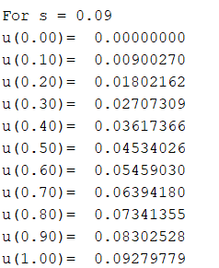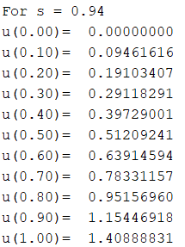 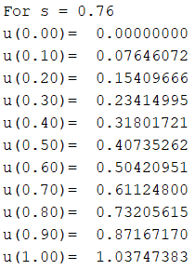

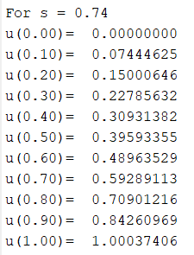 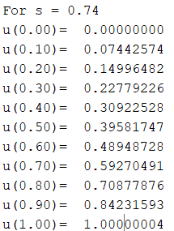

Q3.

Matlab **Code:**

clear

y=zeros(1,11);

v=zeros(1,11);

z=zeros(1,11);

w=zeros(1,11);

phi=zeros(1,5);

Dphi=zeros(1,5);

s=zeros(1,6);

b = [1 2 2 1];

h= 0.1;

x=(0:0.1:1);

yf=4.0;

s(1)=0.9;

dy = @(x,y,z,v,w) (z);

dz = @(x,y,z,v,w) ((3*y*y)/2);

dv = @(x,y,z,v,w) (w);

dw = @(x,y,z,v,w) (3*y*v); ay=zeros(1,4);az=zeros(1,4);av=zeros(1,4);aw=zeros(1,4);

for a=1:5

fprintf("\nFor s = %2.2f\n",s(a));

z(1)=s(a);

y(1)=1; % u at x= 0 i.e. first element in column matrix u

v(1)=0; w(1)= 1;

for i = 1:11

ay(1) = dy(x(i), y(i),z(i),v(i),w(i));

az(1) = dz(x(i), y(i),z(i),v(i),w(i));

av(1) = dv(x(i), y(i),z(i),v(i),w(i));

aw(1) = dw(x(i), y(i),z(i),v(i),w(i));

ay(2) = dy(x(i) + (h/2), y(i) + (h/2)*ay(1), z(i) + (h/2)*az(1), v(i) + (h/2)*av(1), w(i) + (h/2)*aw(1));

az(2) = dz(x(i) + (h/2), y(i) + (h/2)*ay(1), z(i) + (h/2)*az(1), v(i) + (h/2)*av(1), w(i) + (h/2)*aw(1));

av(2) = dv(x(i) + (h/2), y(i) + (h/2)*ay(1), z(i) + (h/2)*az(1), v(i) + (h/2)*av(1), w(i) + (h/2)*aw(1));

aw(2) = dw(x(i) + (h/2), y(i) + (h/2)*ay(1), z(i) + (h/2)*az(1), v(i) + (h/2)*av(1), w(i) + (h/2)*aw(1));

ay(3) = dy(x(i) + (h/2), y(i) + (h/2)*ay(2), z(i) + (h/2)*az(2), v(i) + (h/2)*av(2), w(i) + (h/2)*aw(2));

az(3) = dz(x(i) + (h/2), y(i) + (h/2)*ay(2), z(i) + (h/2)*az(2), v(i) + (h/2)*av(2), w(i) + (h/2)*aw(2));

av(3) = dv(x(i) + (h/2), y(i) + (h/2)*ay(2), z(i) + (h/2)*az(2), v(i) + (h/2)*av(2), w(i) + (h/2)*aw(2));

aw(3) = dw(x(i) + (h/2), y(i) + (h/2)*ay(2), z(i) + (h/2)*az(2), v(i) + (h/2)*av(2), w(i) + (h/2)*aw(2));

ay(4) = dy(x(i) + h, y(i) + h*ay(3), v(i) + h*av(3), z(i) + h*az(3), w(i) + h*aw(3));

az(4) = dz(x(i) + h, y(i) + h*ay(3), v(i) + h*av(3), z(i) + h*az(3), w(i) + h*aw(3));

av(4) = dv(x(i) + h, y(i) + h*ay(3), v(i) + h*av(3), z(i) + h*az(3), w(i) + h*aw(3));

aw(4) = dw(x(i) + h, y(i) + h*ay(3), v(i) + h*av(3), z(i) + h*az(3), w(i) + h*aw(3));

y(i+1) = y(i) + (h/6)*sum(b.*ay);

z(i+1) = z(i) + (h/6)*sum(b.*az);

v(i+1) = v(i) + (h/6)*sum(b.*av);

w(i+1) = w(i) + (h/6)*sum(b.*aw);

fprintf("u(%2.2f)=%12.6f \n",x(i),y(i));

end

phi(a)=y(11)-yf;

Dphi(a)=v(11);

s(a+1)=s(a)-(phi(a)/Dphi(a));

end

**Output:**

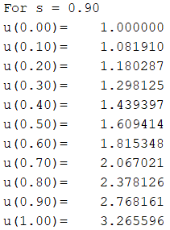 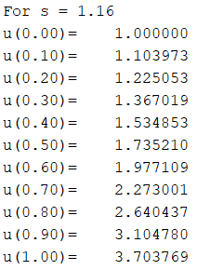 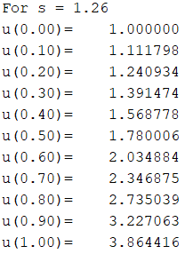

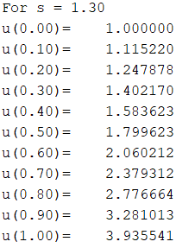 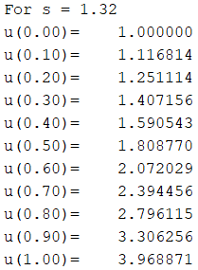

Q4.

**Part 4(i)**

Matlab **Code**

function [X, Y, A, B, L, U] = finite_diff_method_dirichlet(D2y, x_0, y_0, x_n, y_n, h)

syms y(x) y_i_plus_1 y_i y_i_minus_1

Dy = diff(y);

D2y_def = diff(Dy, x, 1);

n = int16((x_n - x_0) / h);

X = double([x_0, zeros(1, n-1), x_n]);

Y = double([y_0, zeros(1, n-1), y_n]);

A = zeros(n-1, n-1);

B = zeros(n-1, 1);

D2y_eq = D2y_def - D2y;

D2y_eq_finite_approx = subs(D2y_eq, {D2y_def Dy y}, {((y_i_plus_1 - 2 * y_i + y_i_minus_1) / (h^2)) ((y_i_plus_1 - y_i_minus_1) / (2 * h)) y_i});

for i=1:n-1

X(i+1) = X(i) + h;

if i==1

B(i, 1) = -1 * subs(D2y_eq_finite_approx, {x y_i_minus_1 y_i y_i_plus_1}, {X(i+1) Y(i) 0 0});

A(i, 1) = subs(D2y_eq_finite_approx, {x y_i_minus_1 y_i y_i_plus_1}, {X(i+1) Y(i) 1 0}) + B(i, 1);

A(i, 2) = subs(D2y_eq_finite_approx, {x y_i_minus_1 y_i y_i_plus_1}, {X(i+1) Y(i) 0 1}) + B(i, 1);

elseif i==n-1

B(i, 1) = -1 * subs(D2y_eq_finite_approx, {x y_i_minus_1 y_i y_i_plus_1}, {X(i+1) 0 0 Y(i+1)});

A(i, n-2) = subs(D2y_eq_finite_approx, {x y_i_minus_1 y_i y_i_plus_1}, {X(i+1) 1 0 Y(i+1)}) + B(i, 1);

A(i, n-1) = subs(D2y_eq_finite_approx, {x y_i_minus_1 y_i y_i_plus_1}, {X(i+1) 0 1 Y(i+1)}) + B(i, 1);

else

B(i, 1) = -1 * subs(D2y_eq_finite_approx, {x y_i_minus_1 y_i y_i_plus_1}, {X(i+1) 0 0 0});

A(i, i-1) = subs(D2y_eq_finite_approx, {x y_i_minus_1 y_i y_i_plus_1}, {X(i+1) 1 0 0}) + B(i, 1);

A(i, i) = subs(D2y_eq_finite_approx, {x y_i_minus_1 y_i y_i_plus_1}, {X(i+1) 0 1 0}) + B(i, 1);

A(i, i+1) = subs(D2y_eq_finite_approx, {x y_i_minus_1 y_i y_i_plus_1}, {X(i+1) 0 0 1}) + B(i, 1);

end

end

L = zeros(n-1, n-1);

U = zeros(n-1, n-1);

for i=1:n-1

if i==1

L(i, 1) = 1;

U(i, 1) = A(i, 1);

else

L(i, i-1) = A(i, i-1) / U(i-1, i-1);

L(i, i) = 1;

U(i, i) = A(i, i) - L(i, i-1) * U(i-1, i);

end

if i<=n-2

U(i, i+1) = A(i, i+1);

end

end

T1 = zeros(n-1, 1);

for i=1:n-1

if i==1

T1(i, 1) = B(i, 1);

else

T1(i, 1) = B(i, 1) - T1(i-1, 1) * L(i, i-1);

end

end

for i=1:n-1

j = n - i + 1;

if i==1

Y(j) = T1(j-1, 1) / U(j-1, j-1);

else

Y(j) = (T1(j-1, 1) - Y(j+1) * U(j-1, j)) / U(j-1, j-1);

end

end

end

syms y(x)

Dy = diff(y);

D2y = 2*y / (x^2) - 1/x;

x_0 = 2;

y_0 = 0;

x_n = 3;

y_n = 0;

h = 1/10;

[X, Y, A, B, L, U] = finite_diff_method_dirichlet(D2y, x_0, y_0, x_n, y_n, h);

**Table:**

|  |  |
| --- | --- |
| X | Y |
| 2.0 | 0 |
| 2.1 | 0.0186 |
| 2.2 | 0.0325 |
| 2.3 | 0.0420 |
| 2.4 | 0.0473 |
| 2.5 | 0.0487 |
| 2.6 | 0.0461 |
| 2.7 | 0.0399 |
| 2.8 | 0.0301 |
| 2.9 | 0.0167 |
| 3.0 | 0 |

**Part 4(ii)**

Matlab **Code:**

function [X, Y, A, B, L, U] = finite_diff_method_robinson(D2y, x_0, x_n, a0, a1, r1, b0, b1, r2, h)

syms y(x) y_i_plus_1 y_i y_i_minus_1 y_minus_1 y_n_plus_1

Dy = diff(y);

D2y_def = diff(Dy, x, 1);

n = int16((x_n - x_0) / h);

X = double([x_0, zeros(1, n-1), x_n]);

Y = zeros(1, n+1);

A = zeros(n+1, n+1);

B = zeros(n+1, 1);

y_minus_1 = 2 * h * r1 / a1 + y_i_plus_1 -2 * h * a0 * y_i / a1;

y_n_plus_1 = 2 * h * r2 / b1 + y_i_minus_1 - 2 * h * b0 * y_i / b1;

D2y_eq = D2y_def - D2y;

D2y_eq_finite_approx = subs(D2y_eq, {D2y_def Dy y}, {((y_i_plus_1 - 2 * y_i + y_i_minus_1) / (h^2)) ((y_i_plus_1 - y_i_minus_1) / (2 * h)) y_i});

for i=1:n+1

if i<=n

X(i+1) = X(i) + h;

end

if i==1

D2y_temp = subs(D2y_eq_finite_approx, y_i_minus_1, y_minus_1);

B(i, 1) = -1 * subs(D2y_temp, {x y_i y_i_plus_1}, {X(i) 0 0});

A(i, 1) = subs(D2y_temp, {x y_i y_i_plus_1}, {X(i) 1 0}) + B(i, 1);

A(i, 2) = subs(D2y_temp, {x y_i y_i_plus_1}, {X(i) 0 1}) + B(i, 1);

elseif i==n+1

D2y_temp = subs(D2y_eq_finite_approx, y_i_plus_1, y_n_plus_1);

B(i, 1) = -1 * subs(D2y_temp, {x y_i_minus_1 y_i}, {X(i) 0 0});

A(i, n) = subs(D2y_temp, {x y_i_minus_1 y_i}, {X(i) 1 0}) + B(i, 1);

A(i, n+1) = subs(D2y_temp, {x y_i_minus_1 y_i}, {X(i) 0 1}) + B(i, 1);

else

B(i, 1) = -1 * subs(D2y_eq_finite_approx, {x y_i_minus_1 y_i y_i_plus_1}, {X(i) 0 0 0});

A(i, i-1) = subs(D2y_eq_finite_approx, {x y_i_minus_1 y_i y_i_plus_1}, {X(i) 1 0 0}) + B(i, 1);

A(i, i) = subs(D2y_eq_finite_approx, {x y_i_minus_1 y_i y_i_plus_1}, {X(i) 0 1 0}) + B(i, 1);

A(i, i+1) = subs(D2y_eq_finite_approx, {x y_i_minus_1 y_i y_i_plus_1}, {X(i) 0 0 1}) + B(i, 1);

end

end

L = zeros(n+1, n+1);

U = zeros(n+1, n+1);

for i=1:n+1

if i==1

L(i, 1) = 1;

U(i, 1) = A(i, 1);

else

L(i, i-1) = A(i, i-1) / U(i-1, i-1);

L(i, i) = 1;

U(i, i) = A(i, i) - L(i, i-1) * U(i-1, i);

end

if i<=n

U(i, i+1) = A(i, i+1);

end

end

T1 = zeros(n+1, 1);

for i=1:n+1

if i==1

T1(i, 1) = B(i, 1);

else

T1(i, 1) = B(i, 1) - T1(i-1, 1) * L(i, i-1);

end

end

for i=1:n+1

j = n - i + 2;

if i==1

Y(j) = T1(j, 1) / U(j, j);

else

Y(j) = (T1(j, 1) - Y(j+1) * U(j, j+1)) / U(j, j);

end

end

end

syms y(x)

Dy = diff(y);

D2y = 3 * Dy - 2 * y;

x_0 = 0;

x_n = 1;

h = 1/10;

a0 = 2;

a1 = 1;

r1 = 1;

b0 = 1;

b1 = 1;

r2 = 2 * exp(1) + 3 * exp(2);

[X, Y, A, B, L, U] = finite_diff_method_robinson(D2y, x_0, x_n, a0, a1, r1, b0, b1, r2, h);

**Table:**

|  |  |
| --- | --- |
| X | Y |
| 0.0 | 1.9895 |
| 0.1 | 2.3122 |
| 0.2 | 2.6943 |
| 0.3 | 3.1480 |
| 0.4 | 3.6877 |
| 0.5 | 4.3311 |
| 0.6 | 5.0997 |
| 0.7 | 6.0196 |
| 0.8 | 7.1224 |
| 0.9 | 8.4470 |
| 1.0 | 10.0403 |

**Part 4(iii)**

Matlab **Code:**

% NR Method for non linear variables

y_sol = [1; 1; 1];% [y1; y2; y3]

y_sol_final = [0; 1; 1; 1; 1]; % [y0; y1; y2; y3; y4]

f1 = y_sol(2) - 2*y_sol(1) - (3/32)*(y_sol(1)^2);

f2 = y_sol(3) - 2*y_sol(2) + y_sol(1) - (3/32)*(y_sol(2)^2);

f3 = 1 - 2*y_sol(3) + y_sol(2) - (3/32)*(y_sol(3)^2);

y_pre=[f1 ; f2; f3];

df1_dy1 = -2 - (3/16)*y_sol(1);

df1_dy2 = 1;

df1_dy3 = 0;

df2_dy1 = 1;

df2_dy2 = -2 - (3/16)*y_sol(2);

df2_dy3 = 1;

df3_dy1 = 0;

df3_dy2 = 1;

df3_dy3 = -2 - (3/16)*y_sol(3);

J = ([df1_dy1,df1_dy2,df1_dy3 ; df2_dy1,df2_dy2,df2_dy3 ; df3_dy1,df3_dy2,df3_dy3]^(-1));

fprintf('Iteration y1 y2 y3\n');

fprintf('%i %12.10f %12.10f %12.10f\n',0,1,1,1);

for i = 1:10

y_sol = y_sol - J*y_pre;

fprintf('%i %12.10f %12.10f %12.10f\n',i,y_sol(1,1),y_sol(2,1),y_sol(3,1));

f1 = y_sol(2) - 2*y_sol(1) - (3/32)*(y_sol(1)^2);

f2 = y_sol(3) - 2*y_sol(2) + y_sol(1) - (3/32)*(y_sol(2)^2);

f3 = 1 - 2*y_sol(3) + y_sol(2) - (3/32)*(y_sol(3)^2);

y_pre=[f1 ; f2; f3];

df1_dy1 = -2 - (3/16)*y_sol(1);

df1_dy2 = 1;

df1_dy3 = 0;

df2_dy1 = 1;

df2_dy2 = -2 - (3/16)*y_sol(2);

df2_dy3 = 1;

df3_dy1 = 0;

df3_dy2 = 1;

df3_dy3 = -2 - (3/16)*y_sol(3);

J = ([df1_dy1,df1_dy2,df1_dy3 ; df2_dy1,df2_dy2,df2_dy3 ; df3_dy1,df3_dy2,df3_dy3]^(-1));

end

x_final=[0; 0.25; 0.5; 0.75; 1];

y_sol_final=[0; y_sol(1); y_sol(2); y_sol(3); 1];

fprintf('\n');

fprintf('i x_i y_i \n');

for i=1:5

fprintf('%i %2.2f %12.10f \n',i,x_final(i),y_sol_final(i));

end

**Table:**

|  |  |  |  |
| --- | --- | --- | --- |
| Iteration | y1 | y2 | y3 |
| 0 | 1.0000000000 | 1.0000000000 | 1.0000000000 |
| 1 | 0.2714285714 | 0.5000000000 | 0.7285714286 |
| 2 | 0.2253427019 | 0.4552468499 | 0.7043928902 |
| 3 | 0.2251100550 | 0.4549708427 | 0.7042377297 |
| 4 | 0.2251100479 | 0.4549708332 | 0.7042377242 |
| 5 | 0.2251100479 | 0.4549708332 | 0.7042377242 |
| 6 | 0.2251100479 | 0.4549708332 | 0.7042377242 |
| 7 | 0.2251100479 | 0.4549708332 | 0.7042377242 |
| 8 | 0.2251100479 | 0.4549708332 | 0.7042377242 |
| 9 | 0.2251100479 | 0.4549708332 | 0.7042377242 |
| 10 | 0.2251100479 | 0.4549708332 | 0.7042377242 |

|  |  |  |
| --- | --- | --- |
| i | x_i | y_i |
| 1 | 0.00 | 0.0000000000 |
| 2 | 0.25 | 0.2251100479 |
| 3 | 0.50 | 0.4549708332 |
| 4 | 0.75 | 0.7042377242 |
| 5 | 1.00 | 1.0000000000 |